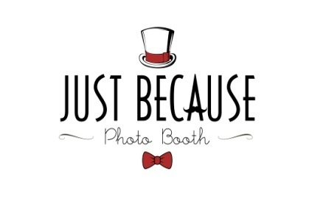

Customer

Name:
Phone: Email:

Event Location

Type of Event: Event Date:
Venue Name: Event Hours:
Venue Address: State: Zip:
Business and Customer Code of Conduct Agreement

The following agreement is to ensure the safety between Just Because Photo Booth’s and Kreativemode Events, LLC’s Staff, Equipment, and Clients.
Just Because Photo Booth Promises to:
- Offer our services with excellence and the upmost professionalism, and in uniform.
- To be courteous to all clientele and respect the rights of others and treat one another with dignity and respect at all times, regardless of economic status, race, color, national or ethnic origin, language group, religion, gender, sexual orientation, gender identity, age or ability;
- Show proper care and regard for client and Business establishment’s property.
I, (The Client), promise to respect Just Because Photo Booth’s terms and conditions.
- Just Because Photo Booth does not allow any kind of liquids or food in or near our photo booths; beverages, alcohol, water, food …Etc. This is for the safety of both JB Photo crew and participants, due to the electronic components and electrical power supply we have a zero tolerance policy and must abide to the given Safety precautions.
- I understand that some intoxicated guests may not handle their composure well, I take full responsibility of individuals who break our agreement of conduct in the means of threatening, harassing, sexually harassing, physically contacting Just Because Photo Booth crew members, in such, giving Just Because Photo Booth the right to terminate their service effective immediately.

Page 1 of 2

Terms & Condition

- Additional Fees: The client shall reimburse Just Because Photo Booth for any additional costs Just Because Photo Booth may occur for parking, which is necessary to the performance of these services.
- Money: A $50 deposit is due at the time of booking to hold the date. The balance will be due upon arrival the day of the event. If you would like to pay your balance in full before the event, that option is available. After booking, In the event the client needs to cancel or change the date, $50 will be returned if cancelation is within 2 weeks of the event. All other monies will be returned to the client within 2 weeks of cancelation. If cancelation is less than 2 weeks, the $50 deposit is non-refundable.
- Appear: If Just Because Photo Booth fails to appear at the place and time specified above without informing the client at least 24 hours in advance, the deposit shall be refunded to the client.
- Copyright: Just Because Photo Booth retains copyright of the photographs, and hereby grants the client unlimited but non-exclusive rights to use or reproduce the photographs for which the client pays Just Because Photo Booth also claims the Right to use certain photos for private use for advertisement on their Website.
- Injuries: Just Because Photo Booth, Kreativemode Events, LLC and its’ affiliates will not be responsible for any accidents or injuries occurring to any of the guests caused directly or indirectly in the use of the rented item's.
- Damages or Losses: The client is responsible for any damages that may occur while Just Because Photo Booth’s equipment is being used, caused by any guests who are present at the client’s event. It is the client’s responsibility to be aware of who’s attending their event. If a person attends the party without client’s consent, the client is still responsible for damages caused by violators. It is the client’s responsibility to cover the costs of repair, up to the value of the equipment.
- Stolen Property: In the event, that the equipment is lost or stolen at the event, the client will pay owner its current value.
- Applicable Law: This contract shall be governed by the laws of the County of Los Angeles, in the State of California and any applicable Federal law.

*Signing of this document is proof that you have read and understand all of the terms and conditions of Just Because Photo Booth’s agreement.

Agreement

Name: Date:

Signature:

Just Because Photo Booth is owned and operated by Kreativemode Events, LLC.

Page 2 of 2

